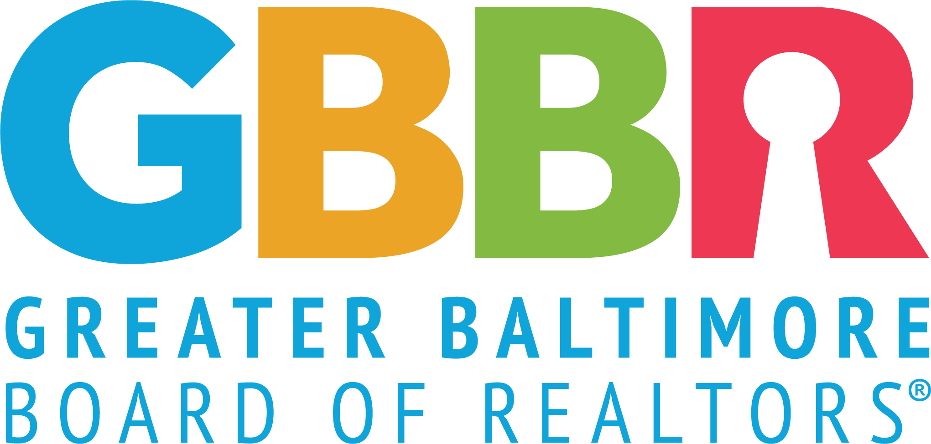

2026 Affiliate of the Year Award

GBBR 2026 REALTOR® Awards
Affiliate of the Year
Official Entry Form

Name: ______________________________________________

Company: _____________________________________________ ______________________________________________

Business Address: ______________________________________ ______________________________________________

Home Address: _________________________________________ ______________________________________________

Each year, the Greater Baltimore Board of REALTORS® gives an award for outstanding achievement to an affiliate member of the Board. These individuals are the lifeblood of our organization. Without the continued support and dedication of our members we would not be the organization we are today.

To be considered for the Affiliate of the Year Award, please submit the completed application and return to GBBR no later than September 30, 2025.

2026 Affiliate of the Year Application

Local Board/Association Activity (60%)
Service on local board/association committees; offices held; special assignments; membership and offices held in local chapters of institutes, societies and councils. (please include years of service)

Business, Education, Designations (20%)
Outstanding business conduct; seminar activity and education course work; designations held and/or candidate for designation; acquired job knowledge through various real estate and related courses, institutes and seminars. (Please give examples of business accomplishments and good conduct with actual incidents, letters, etc.)

Civic Activity (20%)
Local, state and national level participation in civic and service clubs, charitable activities, political action, fraternal or religious groups, etc. Include work that “exhibits extraordinary and self-sacrificing acts of public service to the community.” It is important that the volunteer work extends beyond the scope of the local board even though this work can be included.

Personal Information
(This is optional, but necessary for the development of news releases)
Education, major interests, previous employment experiences, spouse’s name, children, etc.

